***Assignment 1 – software design 2024***

Vaida Diana-Laura

group 3

The UML diagram

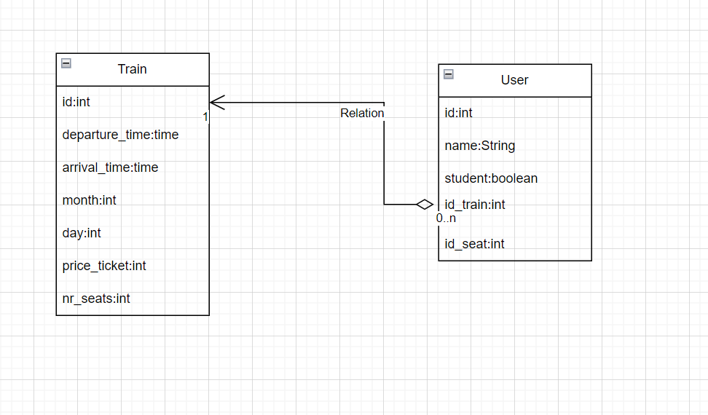

My application is for managing a railway station online( like CFR). For the moment I have only two tables in a one to many relationship (the train and the user). A train can have more users(people going with that train).

The train has an id associated with it, the departure time, arrival time, month, day and the price ticket(standard).

The user has an id, name, the option of being a student or not, the id of the train and id of the seat. For the moment I have only 2 tables, later I will add more, tables for tickets, cities.

I have 4 main packets: Service, Repository, Entity and Controller, and the main class.

In the ‘application.properties’ from the ‘resources’ I connect to my database containing the tables. I checked if my CRUD operations work using PostMan. I tried to implement all the functionalities in the assignment.

In the future I want to add more functionalities – to calculate the specific price ticket (considering if a user is a student or not), checking if the train is already full (using the number of seats), adding a table for cities (what trains belong to what city).